

Project Documents On

RPS Online

Library

Submitted To

**SYED ZAHIDUL HASSAN,**

Project Consultant (.Net Framework),

Show & Tell Consulting Ltd.,

Lalmatia Housing Estate, Lalmatia, Dhaka

**In fulfillment for the award**

**Of**

**IDB-BISEW IT Scholarship Project**

**IN**

**Enterprise Systems Analysis and Design- C# .NET (ESAD - CS)**

**Batch: ESAD-CS/PNTL-M/34/1 Round: 34**

Software Requirements Specification

of

# RPS Online Library

Under the guidance of

**Syed Zahidul Hasan**

**Our project Consultant** (.Net Framework),

IDB-BISEW IT Scholarship Project

Submitted By

Parvez Talukder Id: 1238886 RabiulAwal Id: 1233402

Md. Shah NewajId: 1239198

**ACKNOWLEDGMENTS**

In completing this graduation project we have been fortunate to have help, support and encouragement from many people. We would like to acknowledge them for their cooperation.

First, we would also like to thank **Syed Zahidul Hasan**, our project Consultant, for guiding us through each and every step of the process with his knowledge and support. Thank should not be enough for his advice, guidance and assistance.

Finally, we would like to thank **IDB-BISEW** IT Scholarship Project Authority to make opportunities for us to get a chance to join **Enterprise Systems Analysis and Design - C# .NET (ESAD-CS)** course and finally give chance to choose an awesome project like **RPS Online Library**.

## INTRODUCTION

* **RPS Online Library** is very important now-a-days. It explores the relationship between prosperity, adversity and faith in Almighty. And hence it is important and necessity to our busy life. The country is growing very fast to provide a strong foundation to the young generation to ensure the development of open-minded global citizens securing the future for everyone.

**. RPS Online Library** consists of tasks such as reading books, borrowing books, buy book by ordering, giving orders through online, giving users’ full functional accessibility to UI.

## User Role Based Authorization

**Admin for Borrower Section:**

* Authentication/Log In
* Search book/Add book/Update book/Delete book
* Search category/ Add category Add /Update category /Delete category
* Search Rack/ Add Rack Add /Update Rack /Delete Rack
* Read user feedback/delete user feedback
* Purchases book/Update book/delete book
* Issue book to user
* Check all users
* Calculate fine
* Check all history of issue book and history of fine.
* Search user request/delete or accept user request
* Accept book from user /Calculate fine if late to return

**Admin for Sales Section:**

* Authentication/Log In
* Search book/Add book/Update book/Delete book
* Check pending order/accept order or ship order
* Search stock/Add stock /Update stock /Delete stock
* Add new authenticated user who will perform as Admin.

**Every user should be:**

* Comfortable of working with computer.
* He must have knowledge in online library field.
* He must also have basic knowledge of English too.

**Constraints:**

* GUI is only in English.
* Login and password is used for identification of user and there facilities for guest user also. **Our Proposed System Has Several Advantages**

* User friendly interface
* Fast access to database
* More Storage Capacity
* Add to cart
* Search book
* Look and Feel Environment

## Scope of Work

The purpose of any new technology is to make people life easier. In this project database is used to manage a library and allows the administrators to buy new book and manage new book.

Online library will provide books support and proposed system will do the following tasks:

* Token based authentication is used for all kind of users like User or anonymous and Admin.
* Insert user information such as name, number, and address with all full details.
* Admin, user has to register themselves to the only one system.
* Admin should add new book, category name, rack.
* Admin can also add book details such as photo, calculate unit price, sell price.
* User can see list of books.
* User can add items to the Add to cart menu.
* After that user can order the desired book list.

## Objective

• RPS Online Library is a web based application which connects user & customer are the sources of the books and the user can find their preferred book.

## Technology Used

**Hardware and Software Requirements**

* Operating System: Windows 10
* Processor: Pentium Duel Core or higher
* RAM: 2GB or more
* Hard Drive: 20 GB or more
* ASP.NET MVC4 WebAPI
* AngularJS
* AngularJS Base64
* Entity Framework code first database modeling • Cors applied.
* JavaScript
* jQuery
* jQuery-UI
* HTML5
* CSS3
* Bootstrap
* Bootstrap-Confirmation
* Asp.Net
* Microsoft Visual Studio 2017

* Visual Studio is a complete set of development tools for building ASP.NET Web applications, XML Web Services, desktop applications, and mobile applications. Visual Basic, Visual C#, and Visual C++ all use the same integrated development environment (IDE), which enables tool sharing and eases the creation of mixed-language solutions. In addition, these languages use the functionality of the .NET Framework, which provides access to key technologies that simplify the development of ASP.Net MVC applications and Web API Web Services.

* Angular JS is driven by programs, which define a sequence of operations to be performed on data stored as tables. Although non-programmer graphical user interfaces to Angular JS exist, these GUIs are most often merely a front-end that automates or facilitates the generation of Angular JS programs. The functionalities of Angular JS components are intended to be accessed via application programming interfaces, in the form of statements and procedures.

* Microsoft SQL Server, also known as Microsoft Structured Query Language, is a database management system from Microsoft that combines the relational Microsoft Database Engine with a graphical user interface and software-development tools. It is a member of the Microsoft SQL suite of applications, included in the Professional and higher editions or sold separately.

* Microsoft SQL stores data in its own format based on the Access Jet Database Engine. It can also import or link directly to data stored in other applications and databases.

* Software developers and data architects can use Microsoft SQL to develop application software, and

"power users" can use it to build software applications. Microsoft SQL is supported by Visual Basic for

Applications, an object-oriented programming language that can reference a variety of objects including DAO (Data Access Objects), ActiveX Data Objects, and many other ActiveX components. Visual objects used in forms and reports expose their methods and properties in the VBA programming environment, and VBA code modules may declare and call Windows operating-system functions.

## Proposed System

• The proposed system will be web-based and will be processed by ASP.NET MVC WebAPI and hosted on IIS.

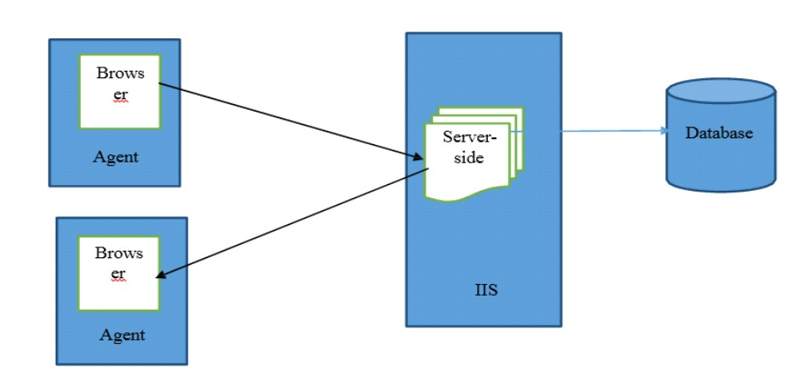

## Data Flow Diagram

Select Book

Search

book

Add

Book to

cart

Order through online

Login

Add book

Manage book

Sell book

Print

Report



User

Admin

**Conclusion:**

Currently, there is some online payment gateway incorporated with this platform. So, companies which register into the system are not able to pay online; payment is done only via check and cash.

Further, the system runs only on Windows platform and is supported only in MS SQL Server database. These are some limitations in the proposed system that needs to be eradicated by introducing new features, sections or modules. As this online library project is somewhat flexible, required new features can be added as per the user requirements.

## Thank You

**Reference Books:**

1. Beginning Microsoft SQL Server 2012 Programming
2. Microsoft Visual C# 2013 Step by Step
3. Object-Oriented Systems Analysis and Design using UML, 3rd Edition
4. PROGRAMMING IN HTML5 WITH JAVASCRIPT AND CSS3
5. Beginning ASP.NET 4.5.1_ in C# and VB
6. Beginning ASP.NET MVC 4 IDB
7. Exam.Ref.70 486.Developing.ASP.NET.MVC.4.Web.Applications 8. AngularJS_using_Parse.com

9. Developing Windows Azure and Web Services Exam.Ref.70-487.